W-Seeds

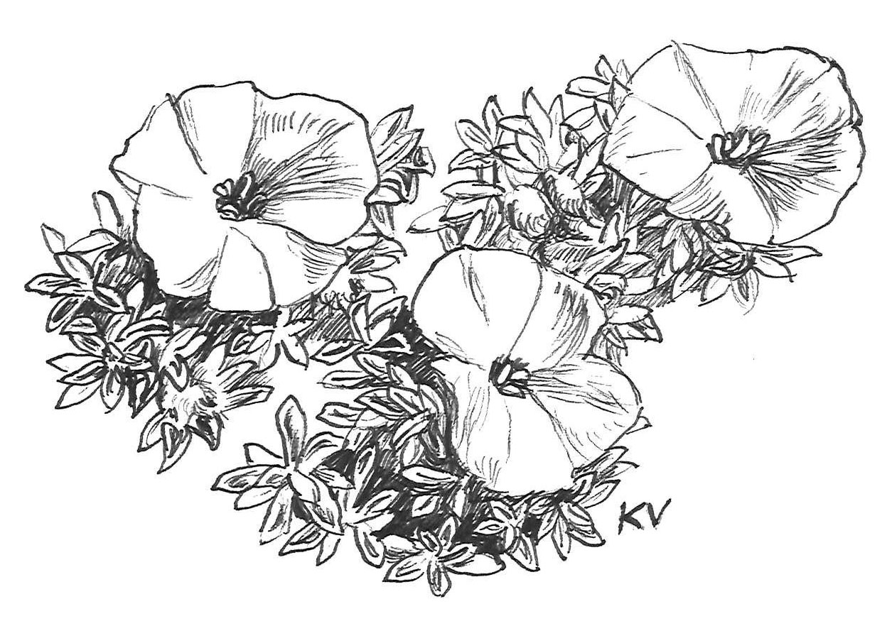
Convolvulus compactus

Vojtech Holubec, Czech Republic
2022/2023

Vojtěch Holubec
Bazantni 1217/5, CZ-165 00 Praha 6, Czech Republic
phone: +420 731 587 826
e-mail: vojtech.holubec@tiscali.cz

November, 2022
Dear rock-garden friends,
Welcome to the 30th seed list 2022/23 available as xls file. The seeds were collected in the wild or in the garden. The garden collections are as valuable as the natural collections and can be collected exactly when become ripe. These species proved to be growable in rock gardens in Central Europe. Those items are clearly marked with ex. The plants were determined according to available Floras. Some plants were not seen in flowers and therefore it is not possible to guarantee all determination. All seeds are marked with a collecting year. Older ones were stored in refrigerator and they keep a good germination ability. Several abbreviations were used in descriptions: pl-plant, lv, lvs-leaves, fl, fls-flowers, infl-inflorescence.
Please, order by both numbers and names to avoid mistakes. Another locality will be selected when the ordered number is gone. Please, list more substitutes, some items are in a very limited supply (less than 10 packets). Minimum order is 30 EUR. I am sorry but there can be no refunds.
Price categories: A Є2.00 B Є2.50 C Є 3.00 D Є 3.50 E Є 4.00 F Є 4.50 Orders over Є 100 take a 5 % discount. Postage and share on charges Є 5.00. All orders receive bonus seed.
Payment by PayPal (attached to e-mail vojtech.holubec@tiscali.cz), by IBAN – on request by e-mail. Cash is possible, in nontransparent registered letter, no regional bills.
Several notes on seed sowing
Use clay or plastic pots with a good drainage hole, put a good drainage on the bottom followed by a layer of light sandy-peaty soil, smooth and press surface, sow seeds thinly, cover with 1-3 mm fine sandy soil, dress surface with 5 mm coarse sand or chippings of 1-2 mm grains, soak the pots and leave them outside, glass protection is recommended against heavy rains but not against snow. Some seeds need to be sown immediately after maturity, most seeds require vernalization over winter and germinate early in spring. Add some snow on top of them (if you have some). For experts: dormant seeds can be treated with gibberelins: make 0.03 % solution of GA3 (in a bit - 3 ml of alcohol and add water), soak the seeds in little Petri dishes for 6 h and sow them. It is good for late sown seeds to replace vernalization and for some old ones. However, overwintering/vernalization is sufficient or even better. Keep the seed pots at least for two years, some germinate slowly, the second or third spring. For more info see also N.Deno instructions.
Books available in discount price for seed customers
The Caucasus and its Flowers by Vojtěch Holubec and Pavel Křivka
The book was printed in December 2006. General chapters: history of botanical research, orography, geology, climate, flora and vegetation, touristic notes. The special part describes 509 species of the Caucasian origin. Format A4, hardcover, over 900 pictures. Price 30 Є plus 12 Є postage, in total 42 Є.
The Flowers of Tian Shan by Vojtech Holubec and David Horák, published in September 2018.
General chapters: history of botanical research, orography, geology, climate, flora and vegetation. The special part describes 621 species of the Tian Shan origin. Format A4, hardcover, over 900 pictures. The price is 40 Є plus 24 Є postage for one book. Orders of 3 and more books can have postage 12 Eur/book. It is a good Christmas gift. If you are interested, please order by e-mail.

Draving: Klára Vlckova-Holubcova

